$C\left(H\right)=\frac{number of edges in G_{H}}{maximum number edges in G_{H}}=\frac{2m_{i}}{n_{i}\left(n_{i}-1\right)}=\frac{2 ×2}{4×3}=\frac{1}{3}$

$$m_{i}:MJ, JK$$

$$n_{i}:E, M, J, K$$

$e\left(M\right)=\max_{j}{\{d\left(M, v_{j}\right)\}}=d\left(M, C\right)=1+2+2+1+3=9$

The distance between M and other nodes are shorter than 9.

$c\left(H\right)=\frac{n-1}{Σ_{j}d\left(H, v_{j}\right)}=\frac{16}{6+4+7+3+1+3+4+3+2+5+2+3+6+3+10+4}=\frac{8}{33}$

1. a. Inflation = 1.1

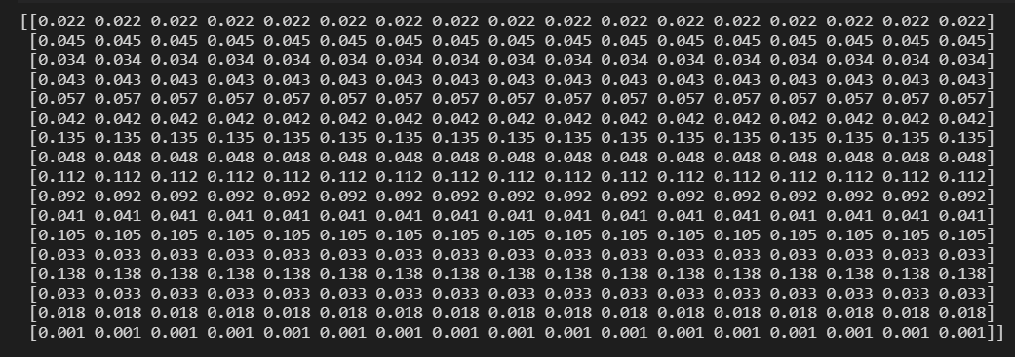

Inflation = 1.3

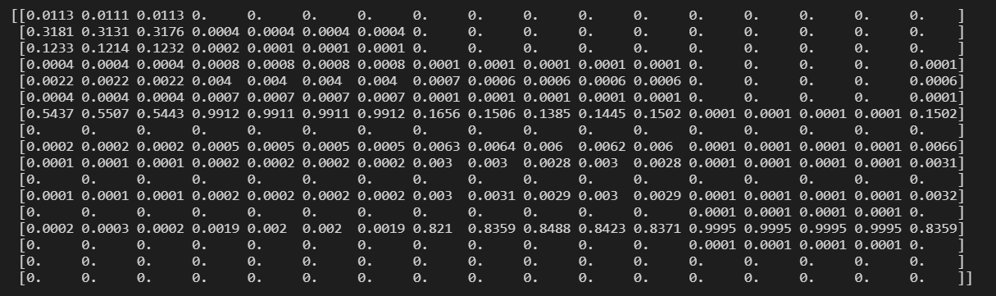

Inflation = 1.5

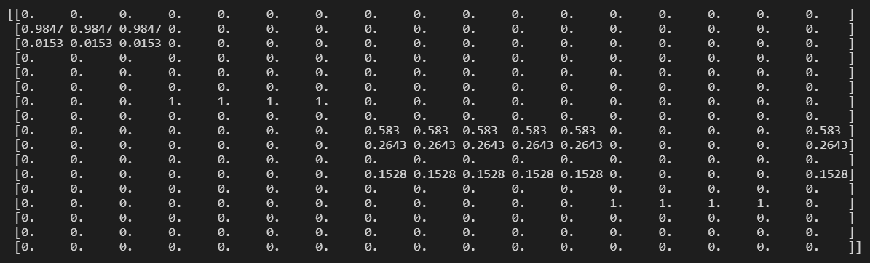

Inflation = 1.7

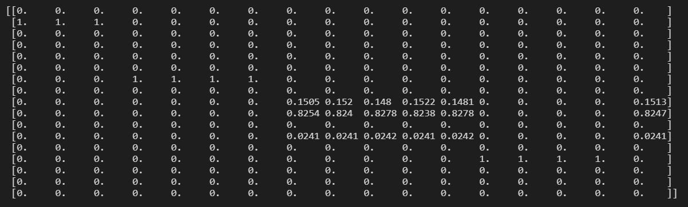

Inflation = 2.1

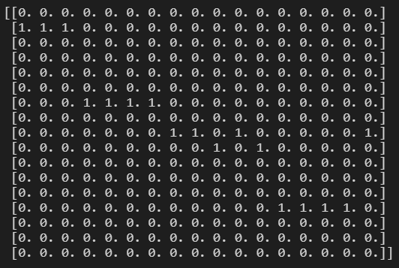

b. The nodes are numbered as following:

0 to 7: A to H, 8 to 12: J to N, 13 to 16: P to S

For each inflation value, the communities are shown below.

Inflation = 1.1

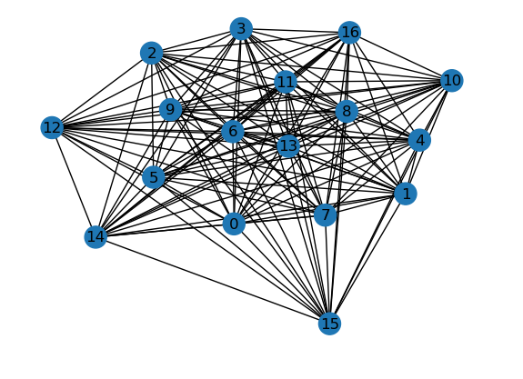

Inflation = 1.3

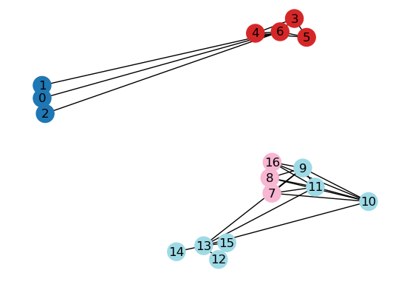

Inflation = 1.5

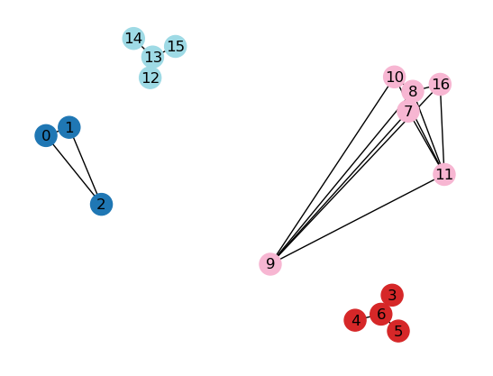

Inflation = 1.7

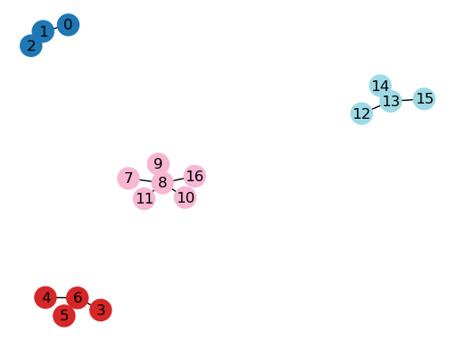

Inflation = 2.1

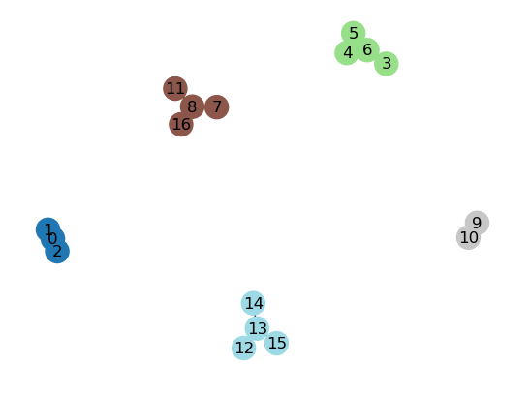

c. Inflation = 1.1

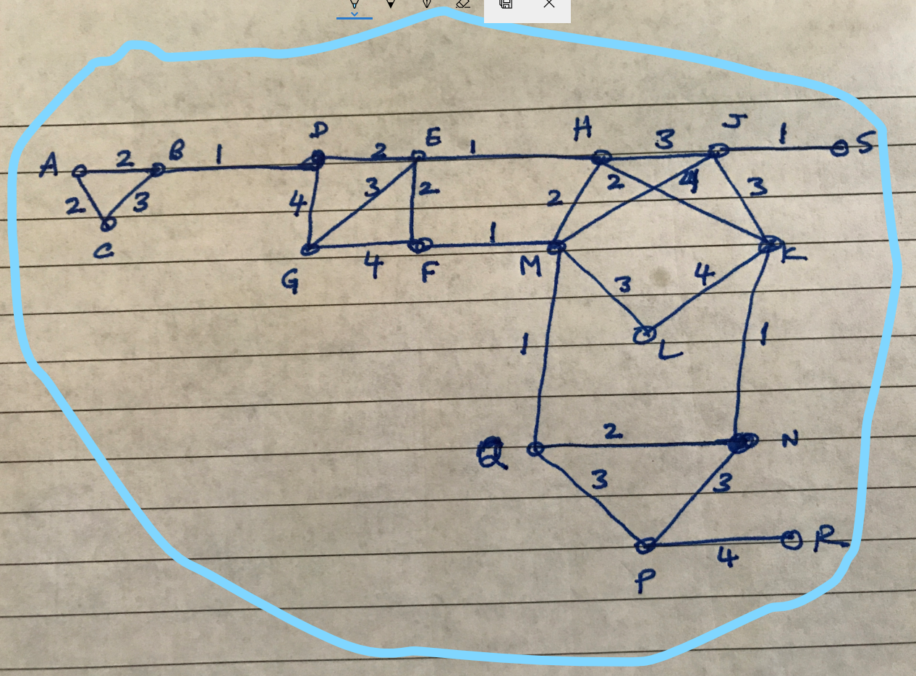

Inflation = 1.3

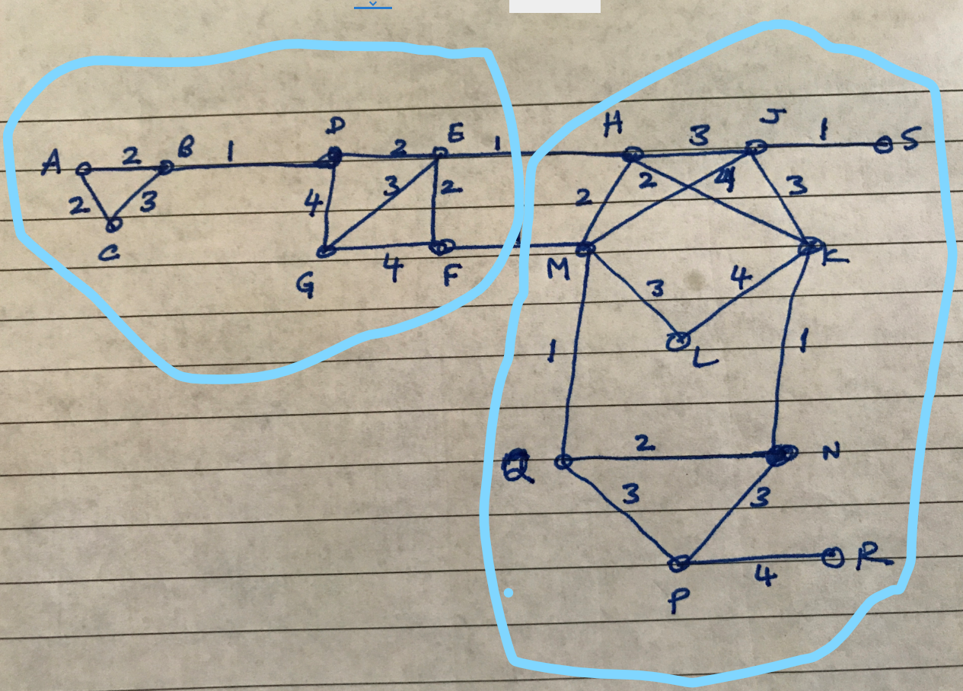

Inflation = 1.5

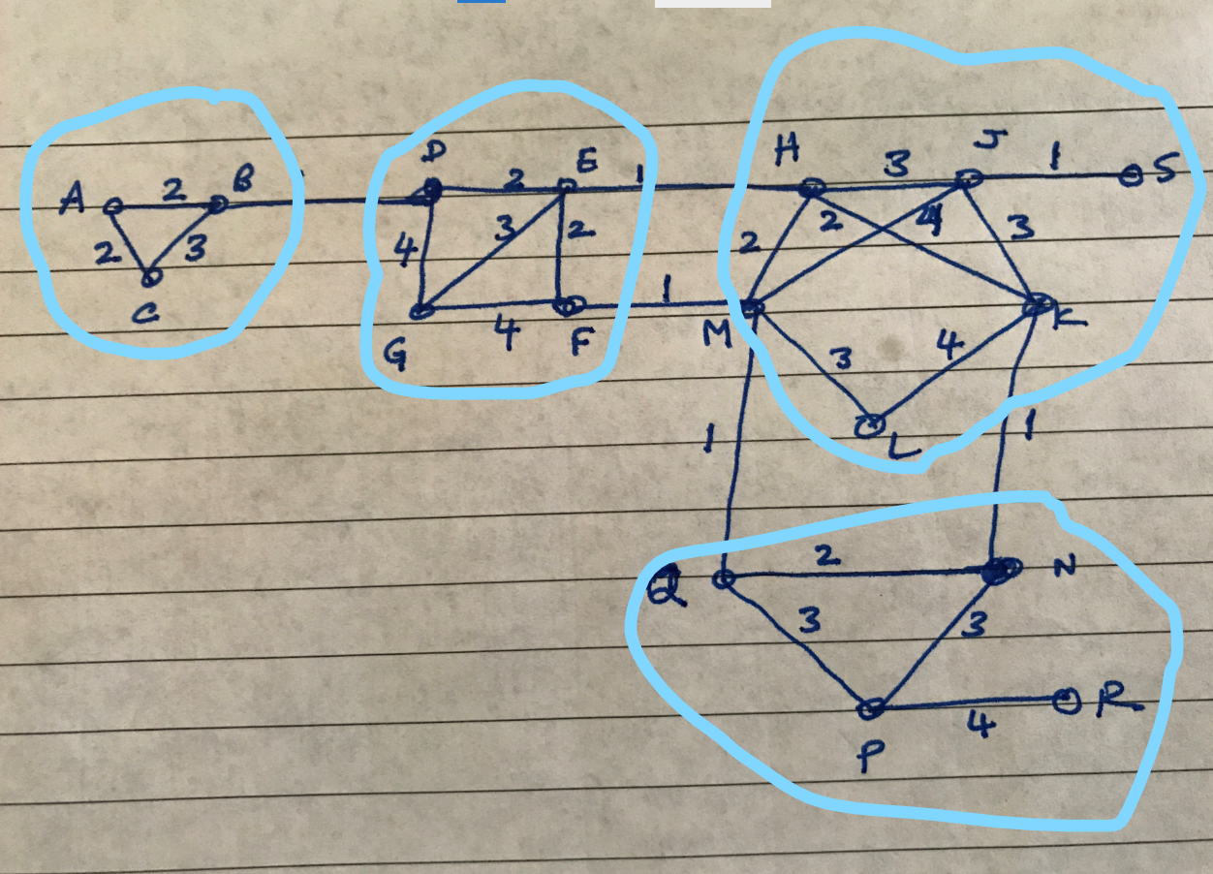

Inflation = 1.7

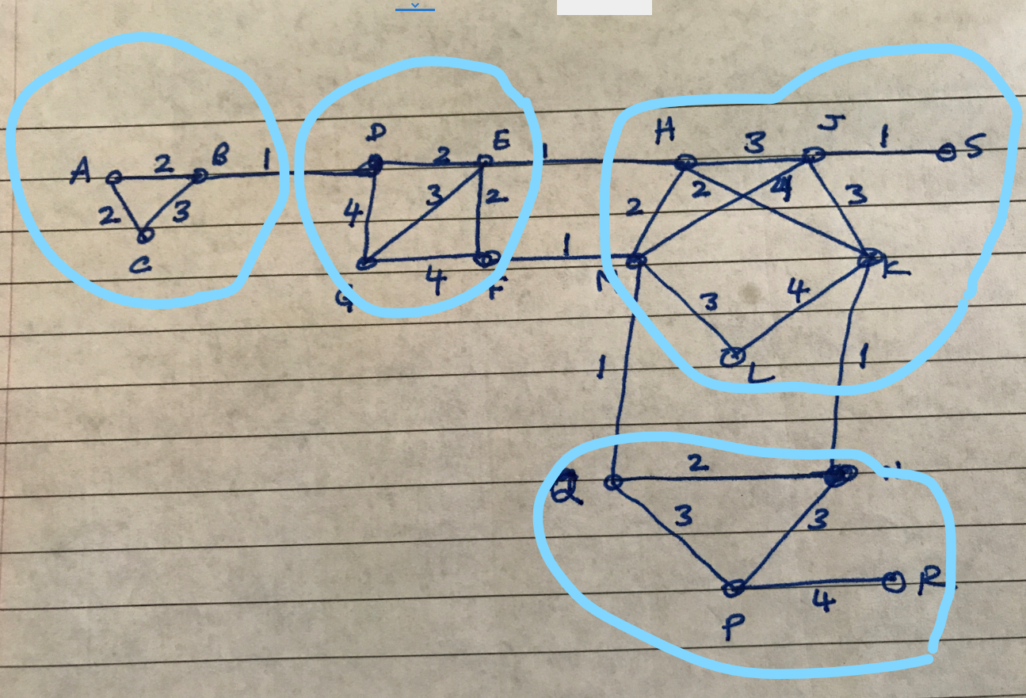

Inflation = 2.1

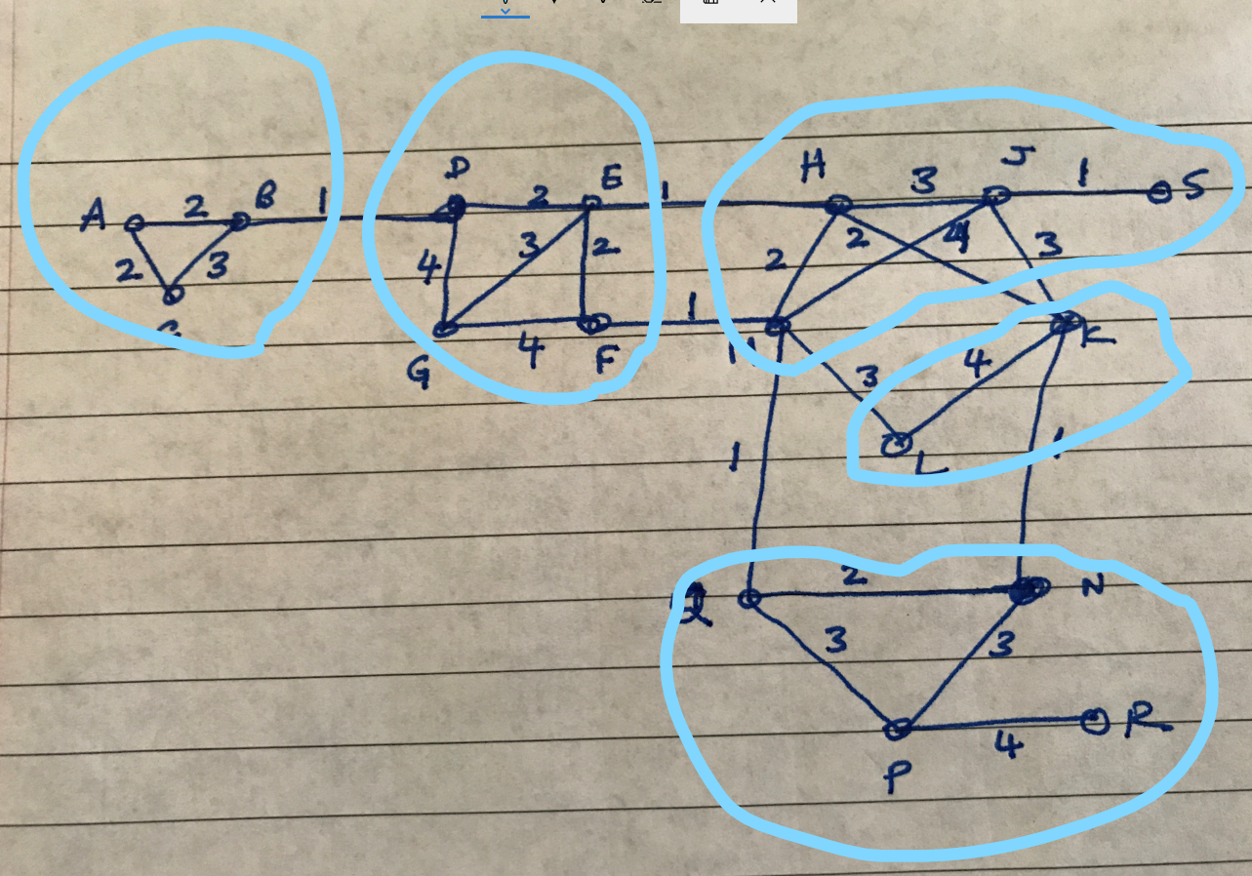

d. Yes. By increasing the inflation rate, we can reduce the size of the communities.

I would like to highly connected subgraph to be in a same community. By changing the inflation rate, we can achieve the desired communities.

The python code is attached below.

Code:

